
TODAY’S DATE:
DATE QUOTE NEEDED (NOT ASAP):
SAMPLES SENT:
ATTN:

REQUEST FOR QUOTE (RFQ)

END USER/REF COMPANY NAME:
STREET ADDRESS:
CITY, STATE ZIP:
END USER CONTACT NAME:
PHONE: | EXT. (IF ANY)
FAX:
E-MAIL:
DISTRIBUTOR (IF ANY):
DISTRIBUTOR CONTACT NAME:

Provide Dimensions In Table Below. Outside Dimensions (Preferred) Inside Dimensions
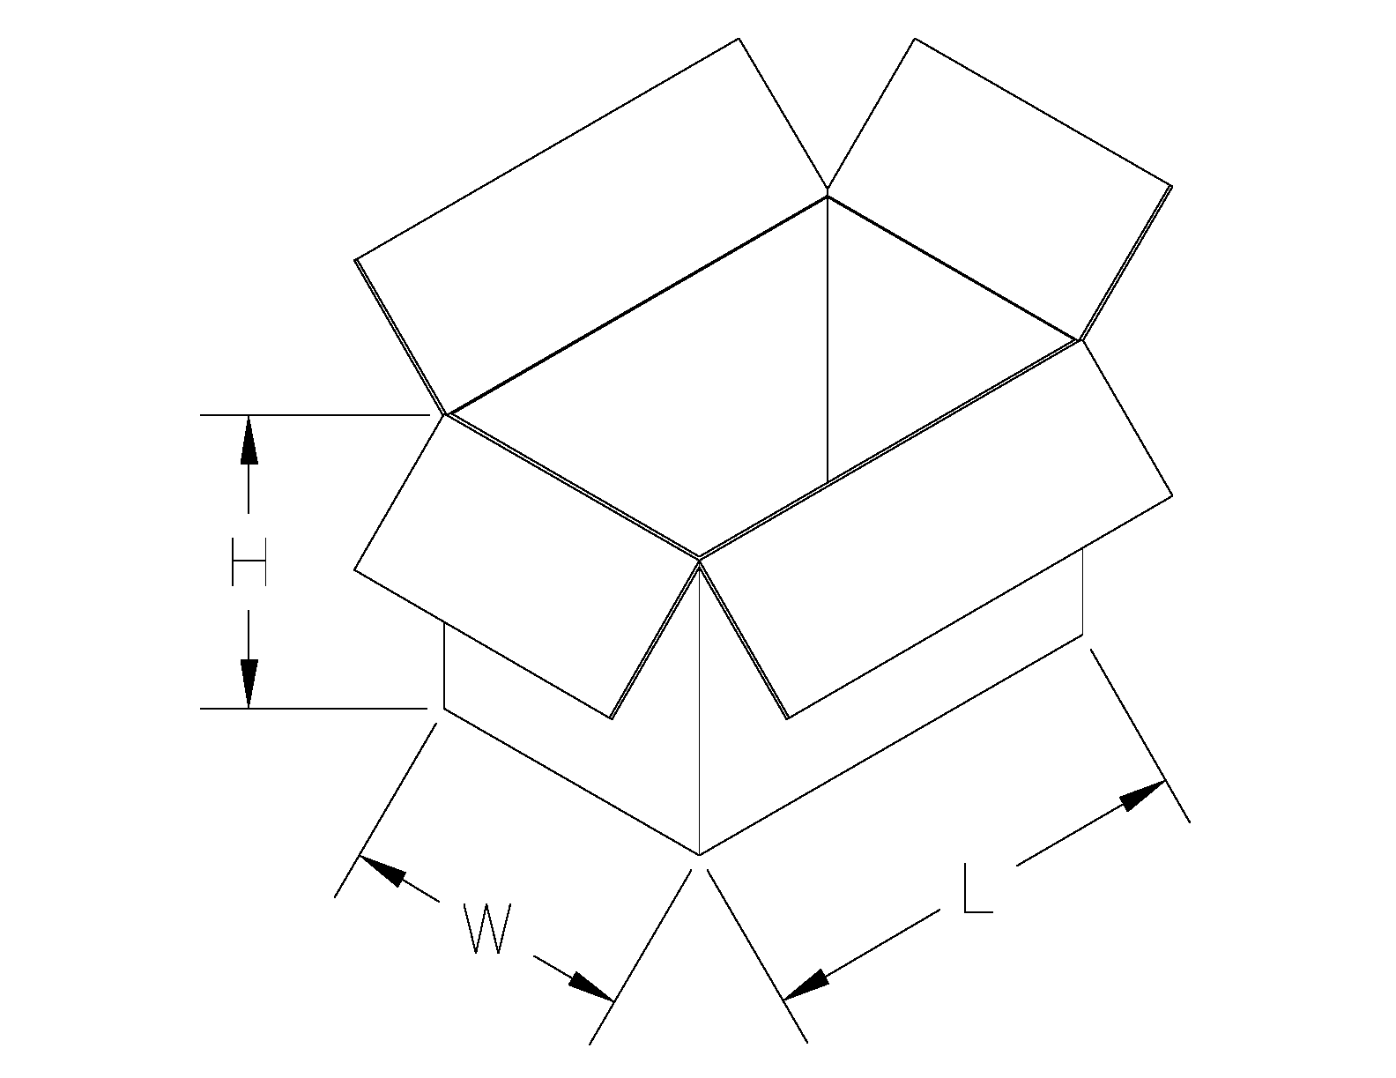
Case Sizes |  |  | Speed | Description | Corrugated
Length | Width | Height | Cases/Min  (CPM) | Case Type |  | Single Wall
 |  |  |  | RSC – Regular Slotted Container |  | Double Wall
 |  |  |  | HSC – Half Slotted Container |  | Triple Wall
 |  |  |  | FOL – Fill Overlapping Flaps |  | Re-shippers
 |  |  |  | AFM – All Flaps Meet |  | Industrial Environmental
 |  |  |  |  |  | Conditions (Check all that apply)
 |  |  |  | ECT: |  | Dry Wet Damp
 |  |  |  | LB TEST: |  | Cold Hot Dusty

Please add any additional case sizes on last sheet under notes, if needed.

Check all that apply if requesting quote for Case Erector or Case Sealer:
Case Erector Bottom Sealer Only
Case Sealer Top Sealer Only
Case Sealer Top and Bottom Sealer

PLEASE NOTE: A completed RFQ helps to expedite an accurate proposal.

Equipment:  (Check All That Apply) |  | Options to Include:  (Check All That Apply)
Case Erector |  | Casters
Case Sealer |  | Low Case Alarm
Combi Random Sealer |  | Low Tape Alarm
3M Matic Sealer |  | Powered Case Magazine
3M Random Sealer |  | 3” Wide Tape Head
Ergopack |  | Hot Melt Glue
Stretch Wrapper (SW10) |  | Stainless Steel Frame
Tray Former - Glue OR Tuck |  | NEMA 4 Wash Down Electric
 |  | Electrical Requirements:
Flat Box Labeler  (Apply Only or Print and Apply) |  | Other:

ACTION REQUIRED ONCE QUOTE IS COMPLETED
Send Quote Via Email to:
Is There a Competing Company for this Quote?
If So, Please Provide Company Name Below:

Email Literature Email Layout. Format Requested PDF Auto CAD

Email Video Links
Schedule a Meeting Schedule a Tour Schedule a Conference Call
Special Notes or additional information needed:

Please send two (2) case samples of each case size PREPAID to OR request pick-up of samples by calling at the below phone number:

Colony Papers, Inc.
(To the attention of your sales representative along with a copy of this form)
1776 Colony Road
York, PA 17408
1-800-221-9577
Fax: 1-717-5567

E-mail completed form to packageit@colonypapers.com

